Calculus with GeoGebra – Local Linearity

GeoGebra is a nice tool for use with explorations of calculus. We will start by constructing an applet that explores the idea of local linearity, that with any function nice enough to be studied in a calculus class, if we zoom in far enough it will look like a line that is indistinguishable from a tangent line. (A second worksheet will do a survey of calculus capabilities.

We start with a fresh GeoGebra window.
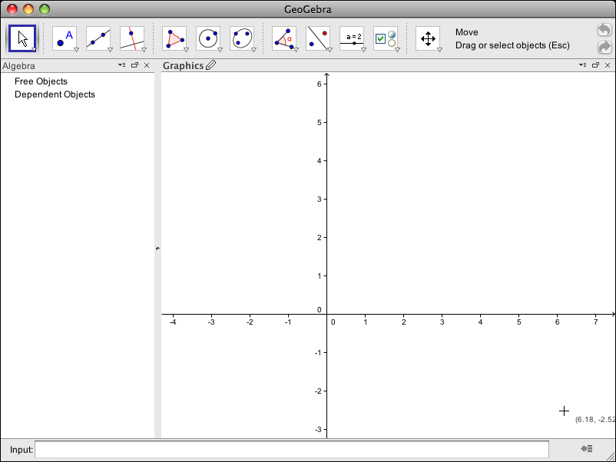

We add our favorite function to the graph by typing it into the input bar. For today, my favorite functions is f(x)=x^2/6-2x+4.
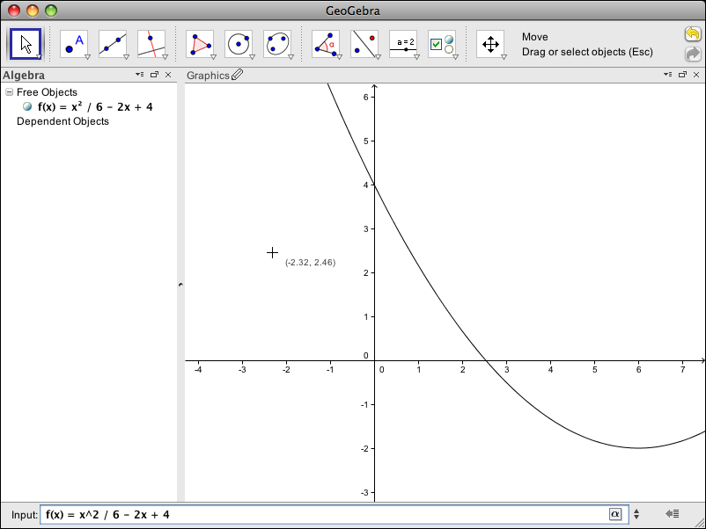

I also use the new point tool to add a point to the graph. If a point starts out on the graph of the function it will be constrained to stay there.
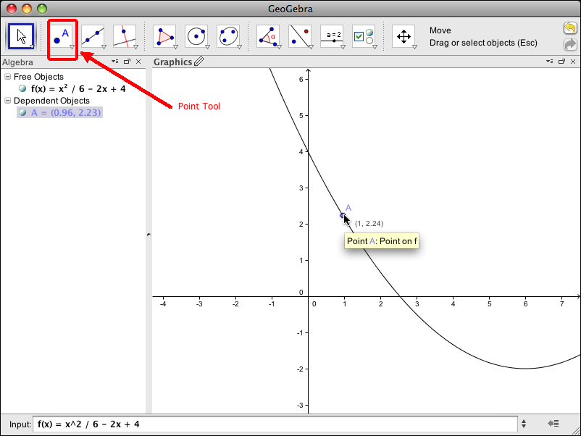
Since I am going to want to zoom in on a point, I create a slider called Zoom that ranges from 0.0001 to 10.
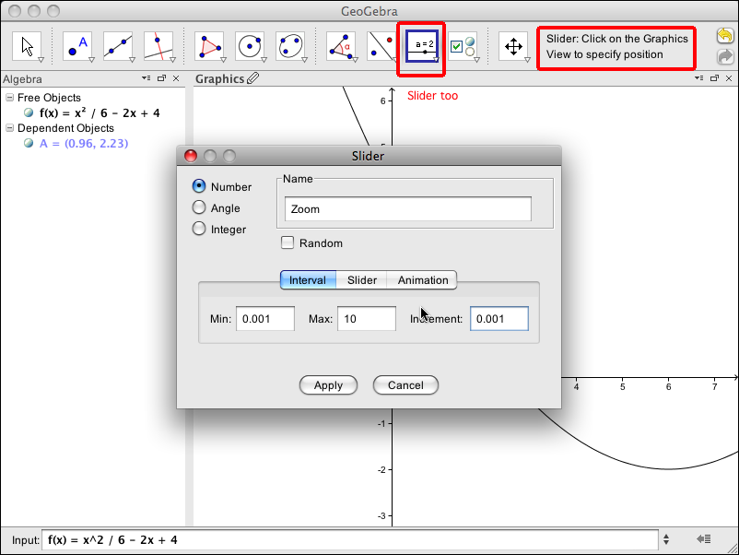

With the slider tab I make it longer
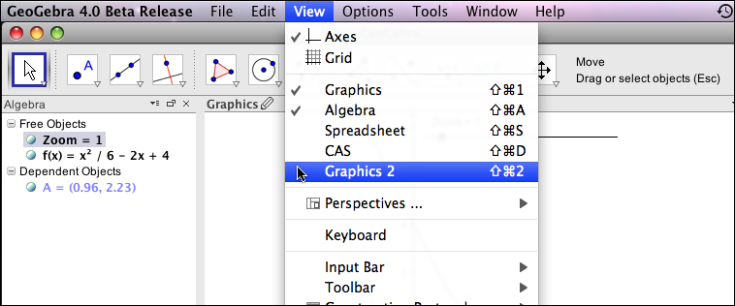

Choose Graphics 2 from the View menu.

Click icon to bring that view into the main panel
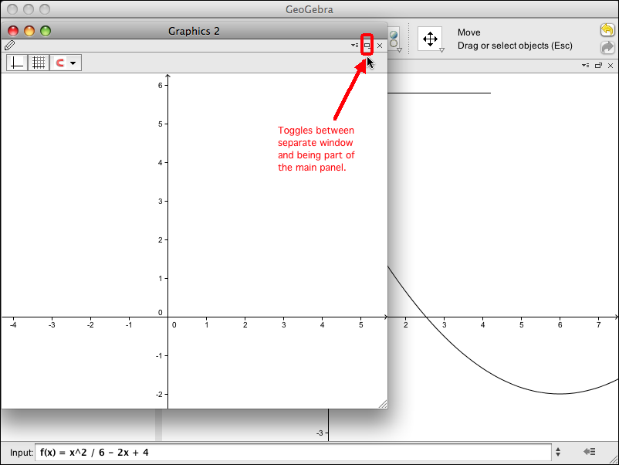

Make the panel wide enough with the corner that changes window size and drag the bar to give the correct amount to each view.
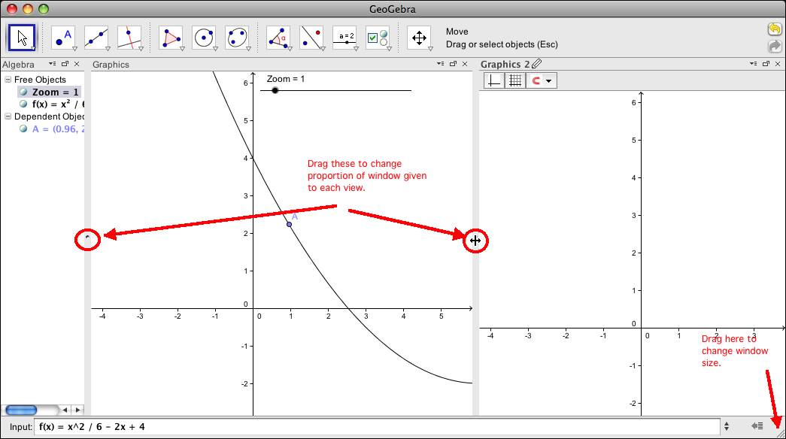

Control click in the graphics window to get a pop up menu. We are interested in the Graphics options. Select that option. (This can also be done from the options menu.)
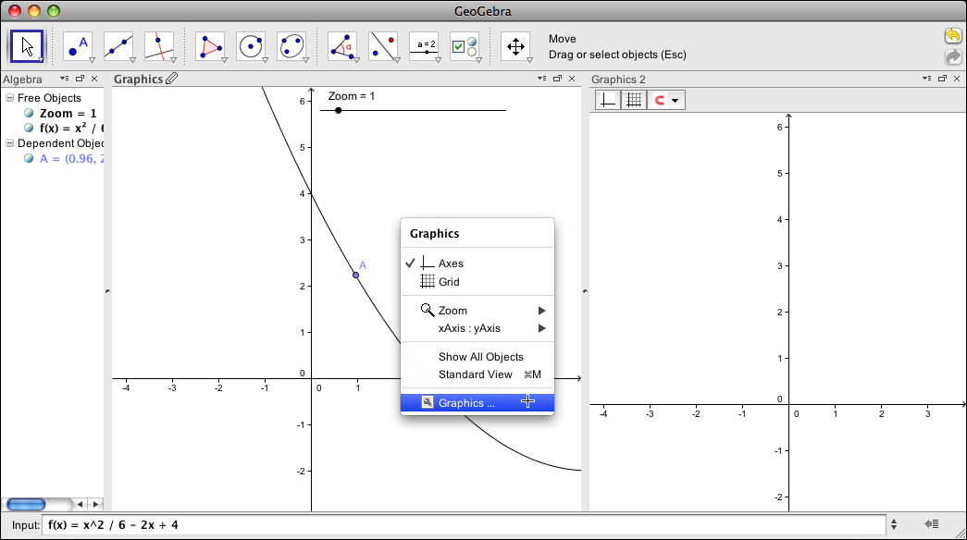

Set the viewing window for the Graphics panel. For this function a nice viewing window has x going from -3 to 10 and y going from -3 to 6.
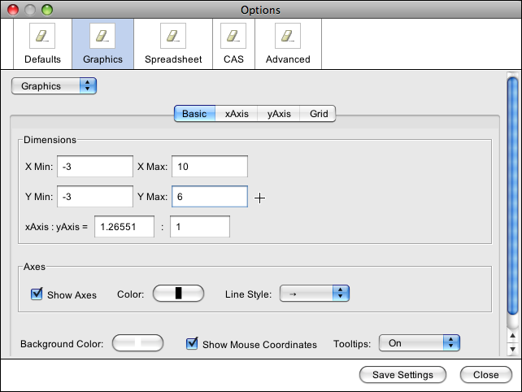

Select the drop down menu for Graphics and select Graphics2.
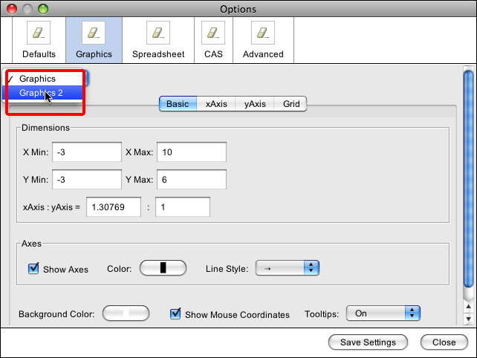

We want the viewing window for Graphics2 to be centered at A and to extend out by Zoom. Thus X min is x(A)-Zoom, or the x coordinate of A minus the value Zoom. Corresponding values are given for X max, Y min, and Y max.
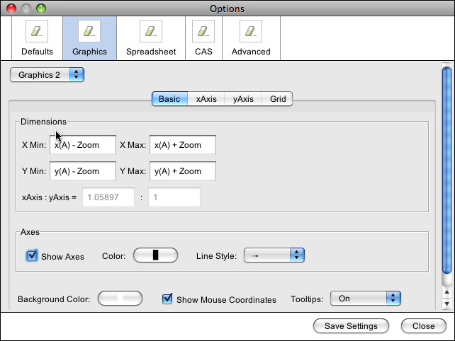

Since we are going to zoom in, we want the axes to stay in sight. We choose the xAxis tab and select the "Stick to edge" option. We repeat this for yAxis.
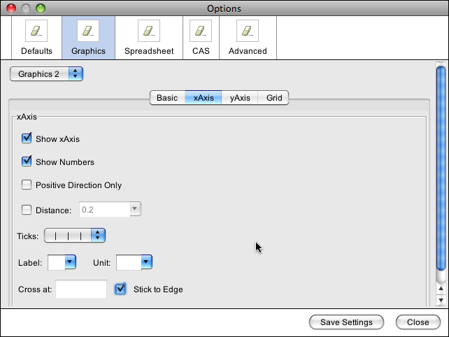

Now we want the objects to show up in both Graphics and Graphics2. Select f(x) in the algebra view and then select Object Properties from the Edit menu. (This can also be done with control click.)
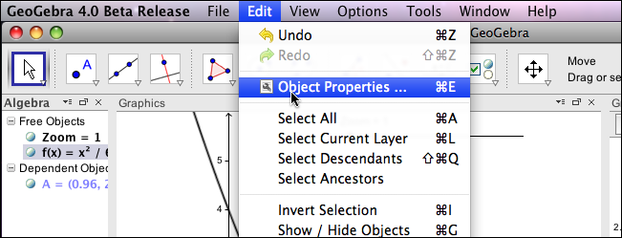

In the Advanced tab in the properties panel, make sure that the check boxes for both Graphics and Graphics2 are selected.
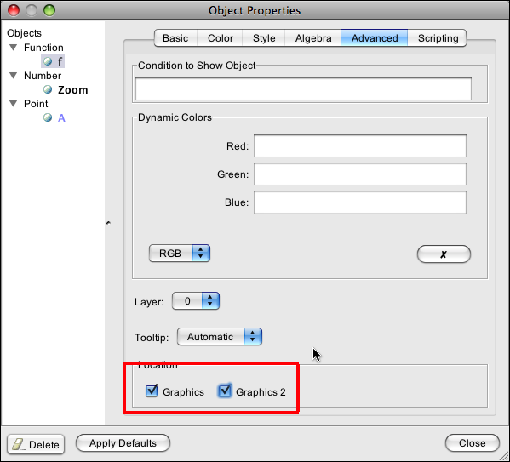

Form the list on the left side of the properties panel, select A, and select both panels for viewing.

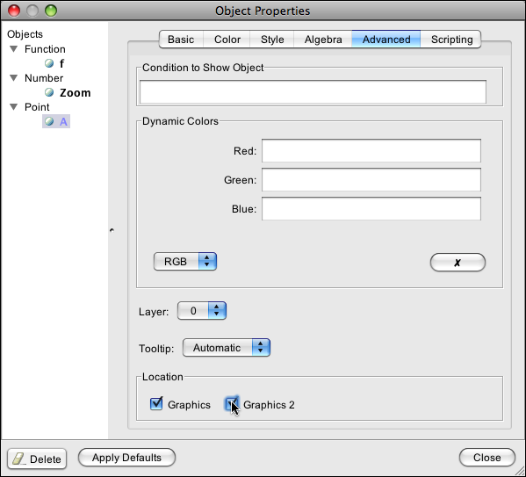

We now have our function and the two viewing windows.
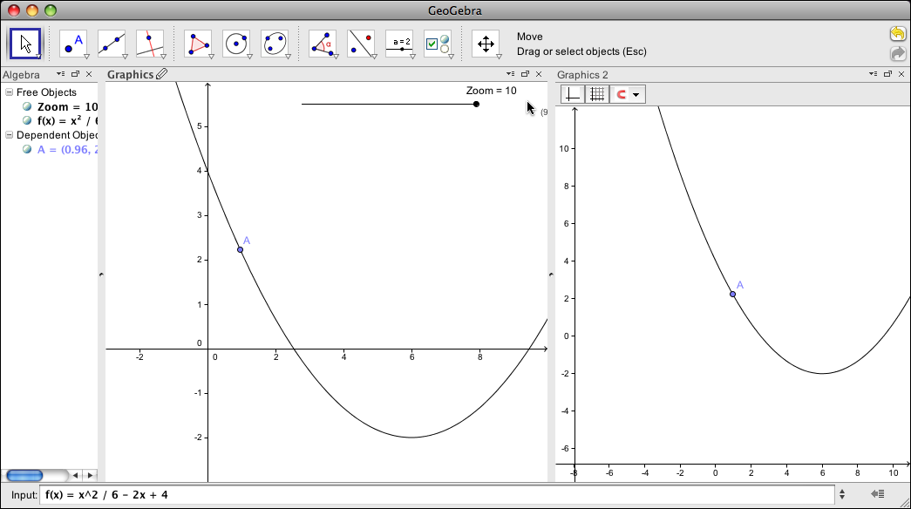

The obvious thing to do is to zoom in and see that the curve through A looks like a line when we zoom in far enough.
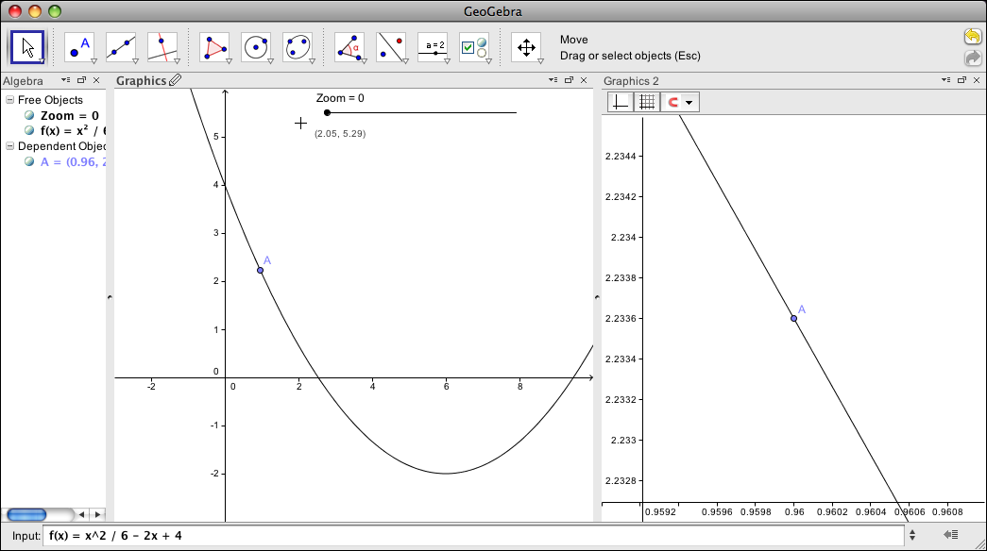

I want to add a box for the zoomed viewing window. I start by defining points C1, C2, C3, and C4 with the appropriate coordinates for the box.
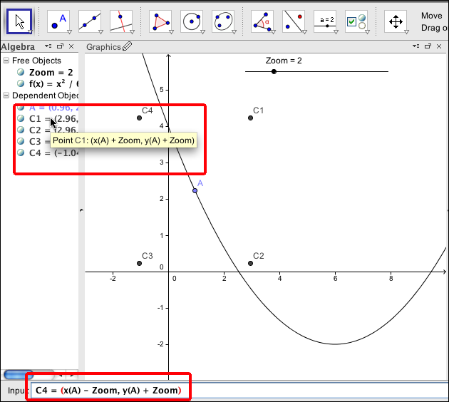

I then use those points and create a rectangle with the polygon tool.
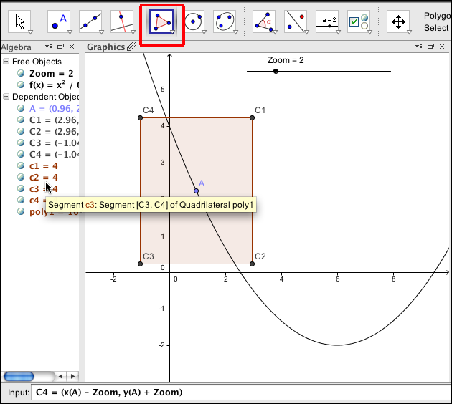

I would like to clean things up so I only have a box here. I start by going to the Object properties and selecting the 4 points and unchecking the box for Show Object.
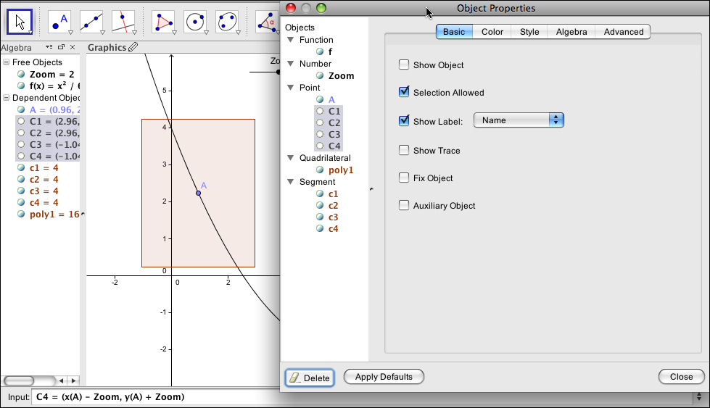

I then go to the polygon in the object list and increase the line thickness while reducing Opacity to zero.
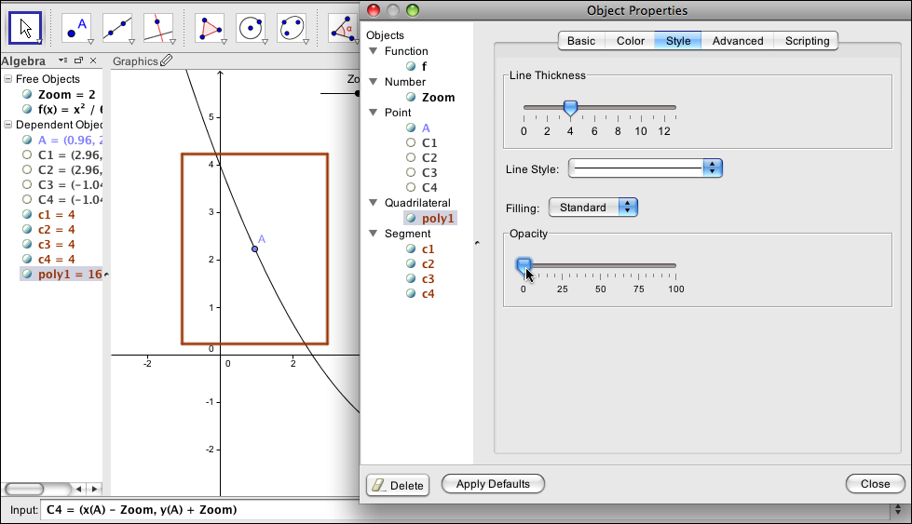

I continue the cleanup by using the basic panel in Object Properties, selecting all of the points, lines, and polygons from the viewing window and making them Auxiliary Objects so they don't show up in the Algebra window.
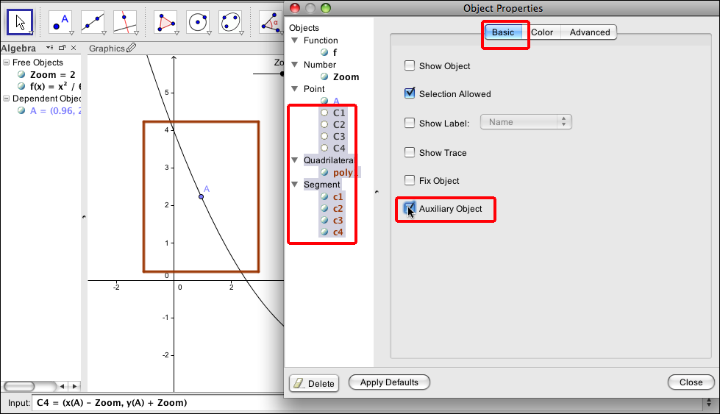

Next we add use the Tangent command to add a line tangent to the graph of f(x) at A.
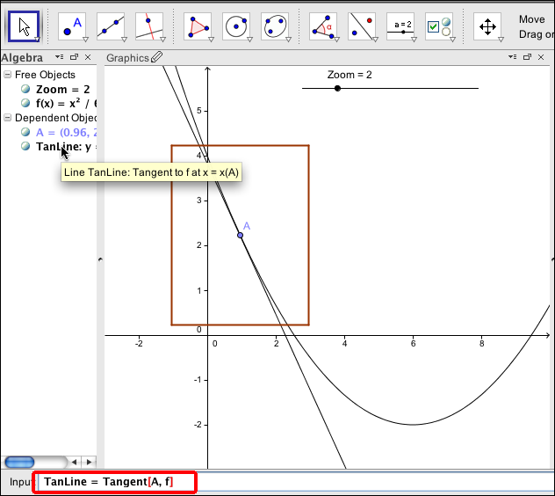

With the Advanced tab of the properties window we want to make TanLine visible in both Graphics and Graphics 2 view, with the Color tab, we make it red, and with the style tab we make it thicker.
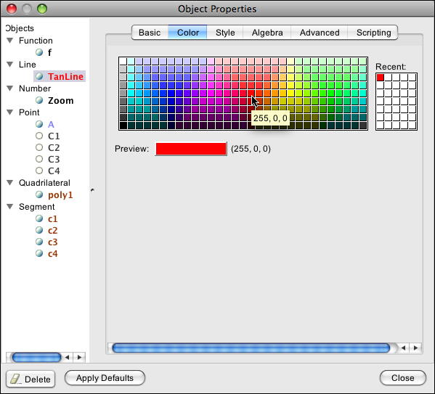

We can now use the drop down menu so that both the graph and the tangent line are labeled by name and value.
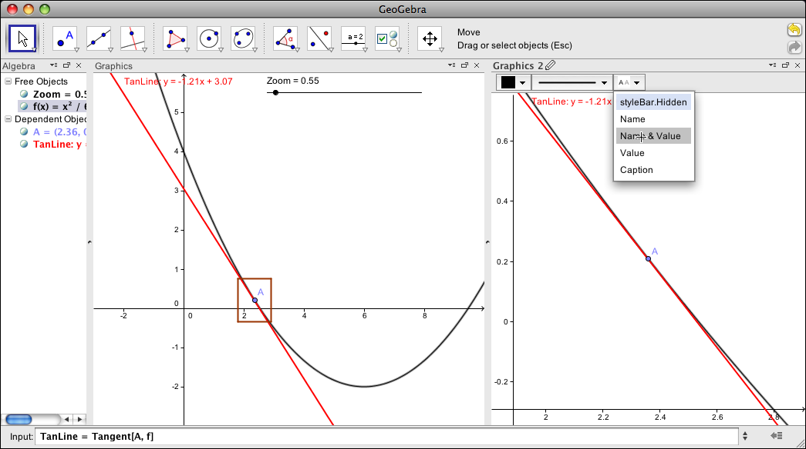

This gives us the demonstration we wanted for local linearity.
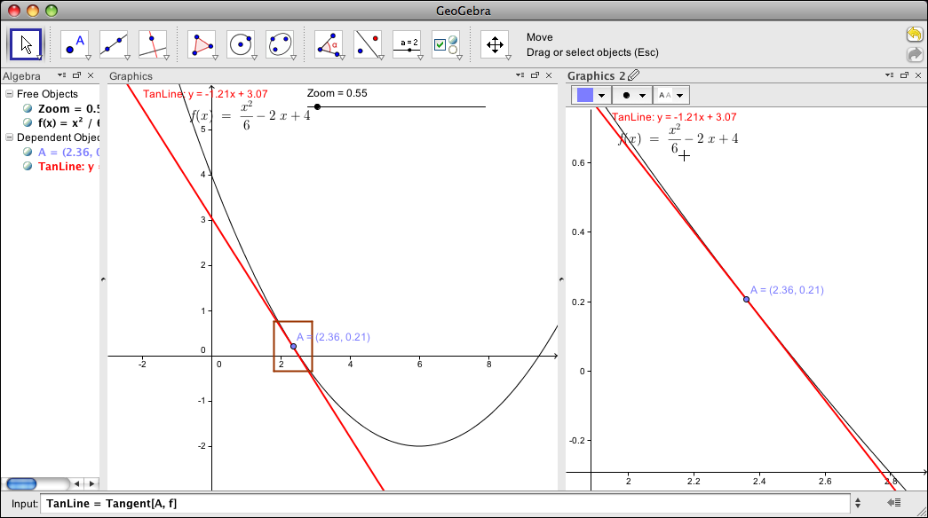

It is worthwhile noting that once we have the construction, we can change the definition of f(x).
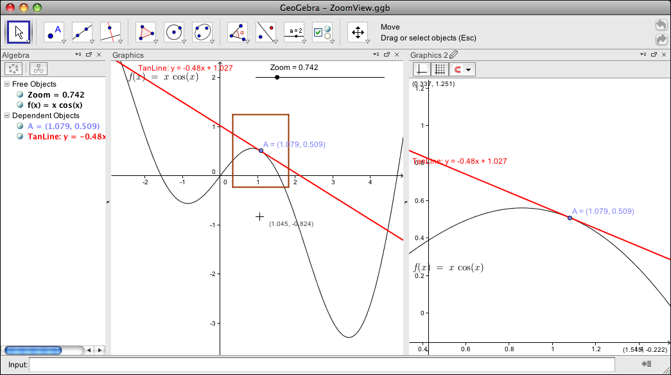

© 2011, Mike May, S.J., Saint Louis University

Except where otherwise noted, content on this site is licensed under a Creative Commons Attribution-NonCommercial-ShareAlike 3.0 license, Mike May, S.J. maymk@slu.edu

