Working with styles with GeoGebra 4.0

With release 4.0, GeoGebra has added ways to change the style of an object. Below the tool menu is a strip that labels the various windows. On the right side of that strip are three icons. The X closes the view. The screen pop up icon is a toggle for that view to have its own window or be part of the strip. The down list icon gives a strip of controls to the graphical window.

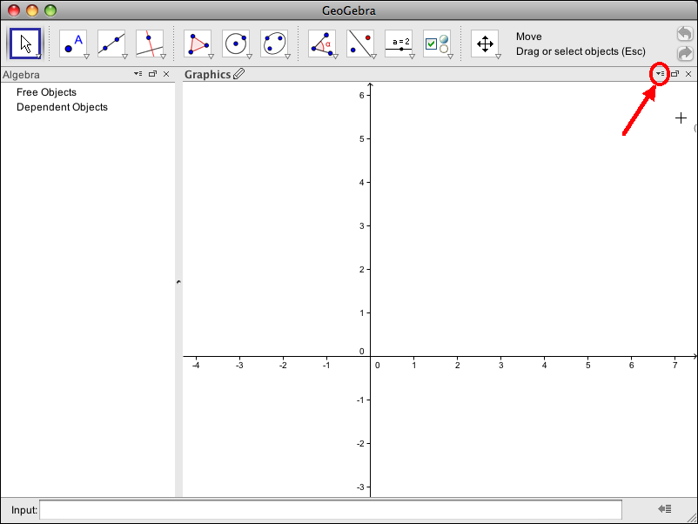

When no objects are selected, we are given controls for the general viewing window. We have icons that can be toggled on or off to show or hid the axes or grid. We also have a drop down behavior that controls how points behave in relation to the grid.
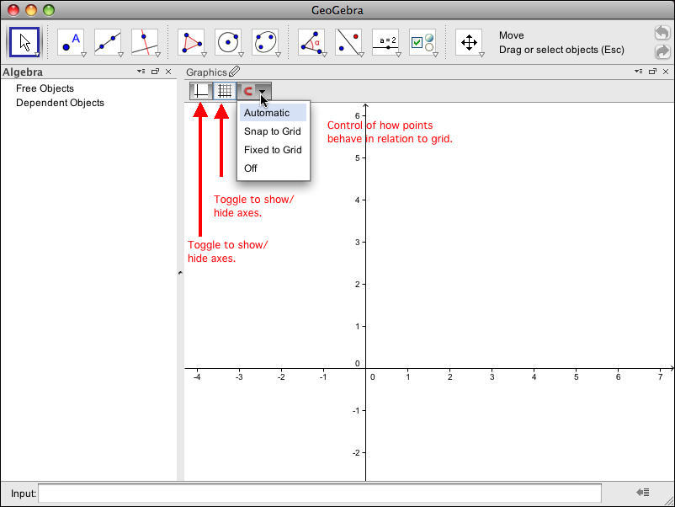

When the point tool is selected, we are given options for the color, style, size, and point capturing action for new points. A color palette lets us choose colors.
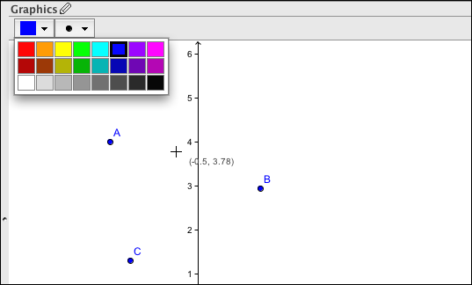

A second palette controls the style and size of the point.
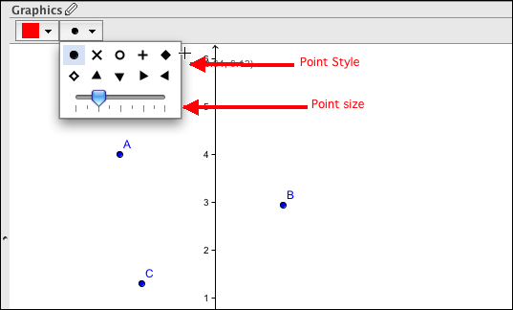

When a particular point is chosen we also have a control for whether the label is visible and what will be included in the label.
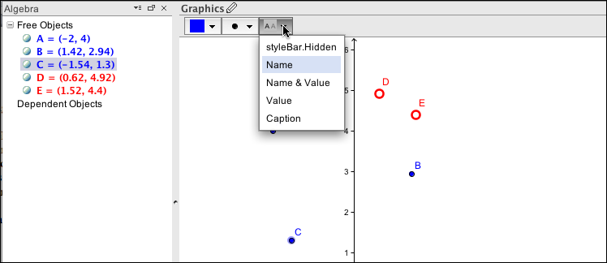
With the visual style tool, the next object clicked is selected. The style of that object is then copied to new objects selected. (Go back to the move tool to unselect the copying.)
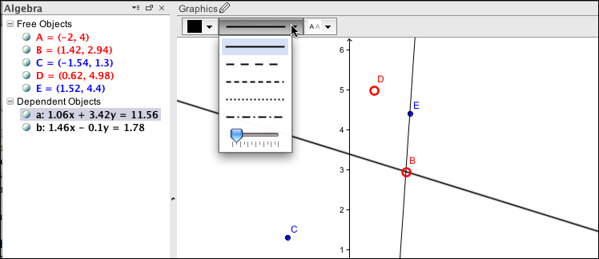
With a line we get color, line style and thickness.

Copying across object types will copy the elements that make sense in both types, like color and label behavior.
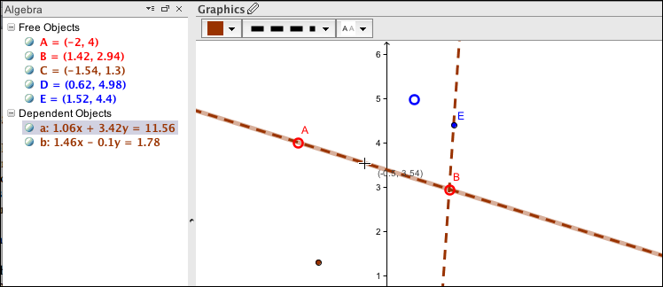

With polygons, in the color palette, there is a slider for fill opacity.
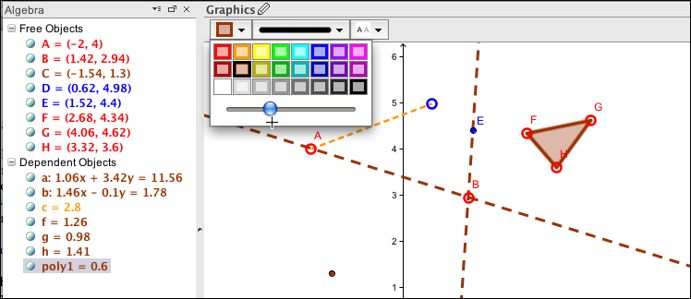

© Mike May, S.J., Saint Louis University

Except where otherwise noted, content on this site is licensed under a Creative Commons Attribution-NonCommercial-ShareAlike 3.0 license, Mike May, S.J. maymk@slu.edu

