The options menu with GeoGebra 4.0

Verified with 3.9.162

It is worthwhile to look at the options menu of GeoGebra.

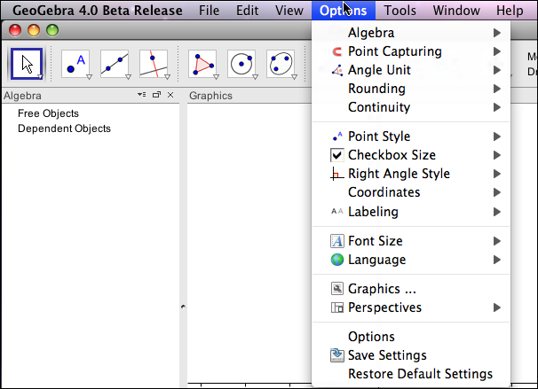

Most of the items in the menu have an arrow to the side that produce a further menu of options of a particular type.

For example, the Algebra item gives the options for viewing items in the algebra window. The default option gives the objects and their values.
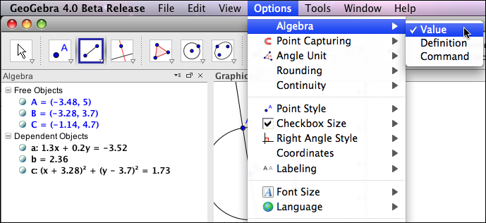

A second option lists the dependent objects with their definitions.
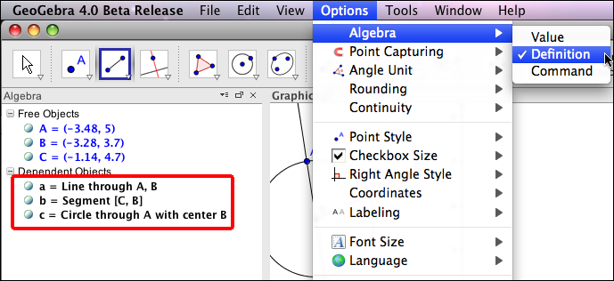

Notice that free objects are still given with values.
The third option for the algebra window is to describe dependent objects with the command used to create them.
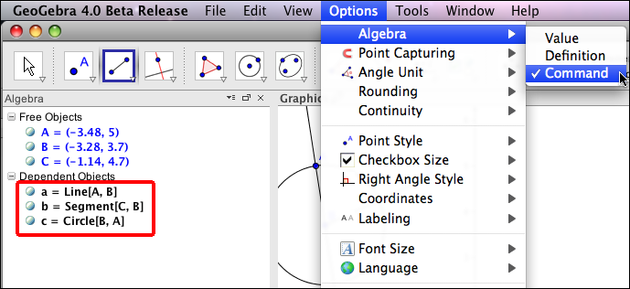

Many of the other options are fairly self-explanatory.

Point capturing refers to whether or not even points get a preference. The default has this feature on. It means that when you drag a point, if it gets close to a lattice point (both coordinates whole numbers), then it will snap to that point.

Angle Unit refers to whether angles are reported in degrees or radians. For most courses there is a best choice here, but it depends on the course as to what that is.

Rounding determines how much of a number is reported when it is listed. Note that this can either be done in terms of decimal places or in terms of significant digits.
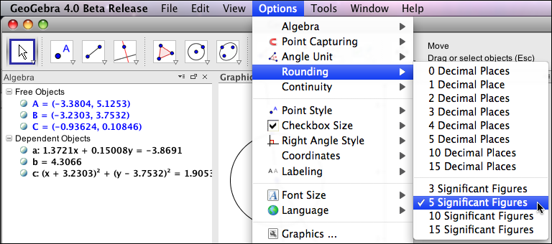
It should be noted that when dragging an object, the stored value will match the rounding conditions.

The Continuity option refers to moving intersection points and the use of near-to heuristics to keep such points from jumping around.

The Point Style, Checkbox Size, and Right Angle Style are self-explanatory. Coordinates controls which convention is used for labeling the coordinates of an ordered pair.

Font Size and Labeling control default behavior for the font size used and whether or not object labels are shown respectively.

The Language option is part of localization. It controls the language used for all the commands and instructions given by GeoGebra.
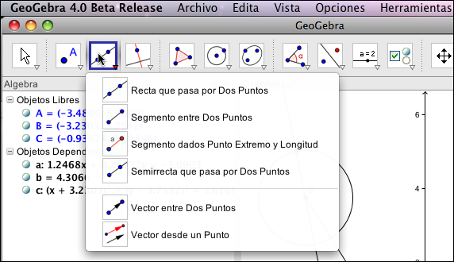

Obviously that feature is quite useful if you are working with students from a non-English background.

The graphics and Options items each pull up a tabbed window. We start by looking at the Graphics tab. We start by noticing that Release 4.0 of GeoGebra gives you 2 graphics windows, Graphics and Graphics2. For each of the graphics windows we have tabs that roughly correspond to the general viewing window, the x-axis, the y-axis and whether or not a grid is shown in the background.

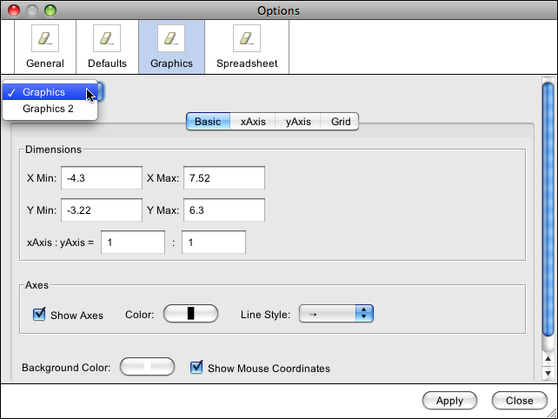

If you look at the options for an axis, there are some features worth pointing out.
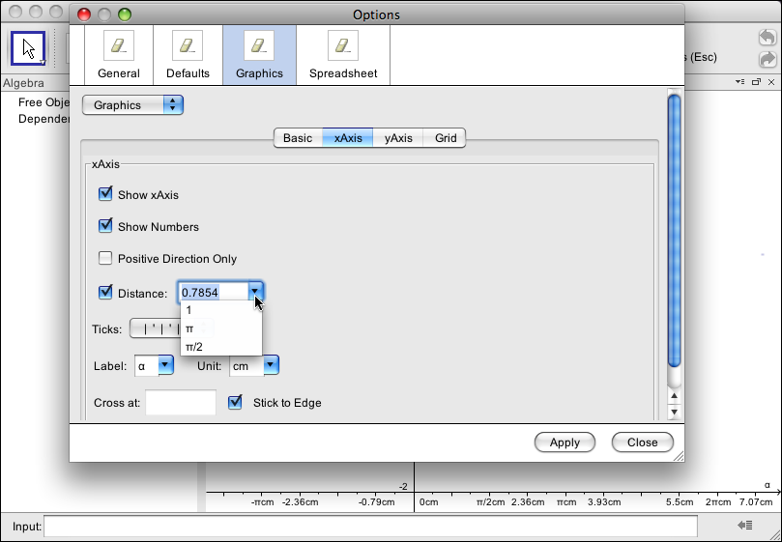

You can specify the units of distance on an axis. Units of 1, π, and π/2 are available by default. As the picture shows, you can also specify other units, like π/4, but they get converted to a decimal equivalent. The axis can be labeled as you wish, since you may want a u-v plane for example. You can also control whether the axis are placed to cross at a specific point (the origin by default, or stick to the edge. This is useful when you want to view a region away from the origin.

Another new feature with release 4.0 is that while the axes are for a Cartesian coordinate system, you can specify that the grid should use polar coordinates.

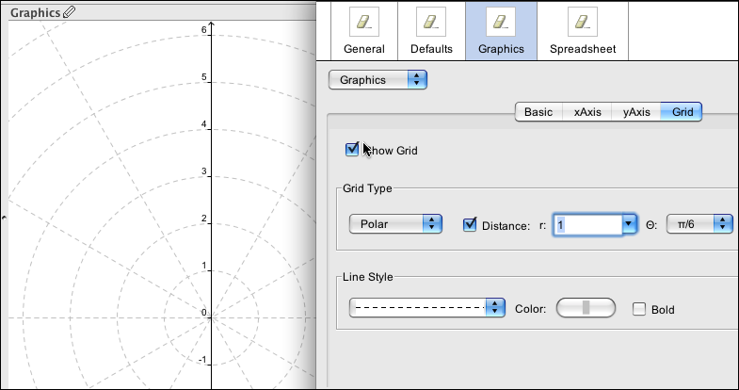

The Defaults tab in the Options window is also worth exploring. (This is also new with release 4.0)
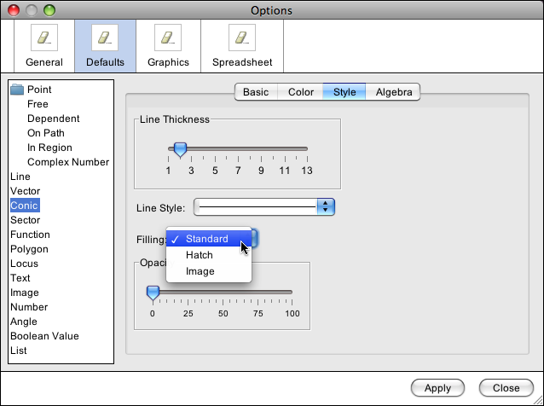

This tab allows you to specify GeoGebra's default behavior when a new object is created. This includes the visual style used, the use of labels, and if the object is fixed or auxiliary.

The items to Save Settings and Restore Default Settings are self-explanatory.

Except where otherwise noted, content on this site is licensed under a Creative Commons Attribution-NonCommercial-ShareAlike 3.0 license, Mike May, S.J. maymk@slu.edu

